

<https://www.overseasvotefoundation.org/>

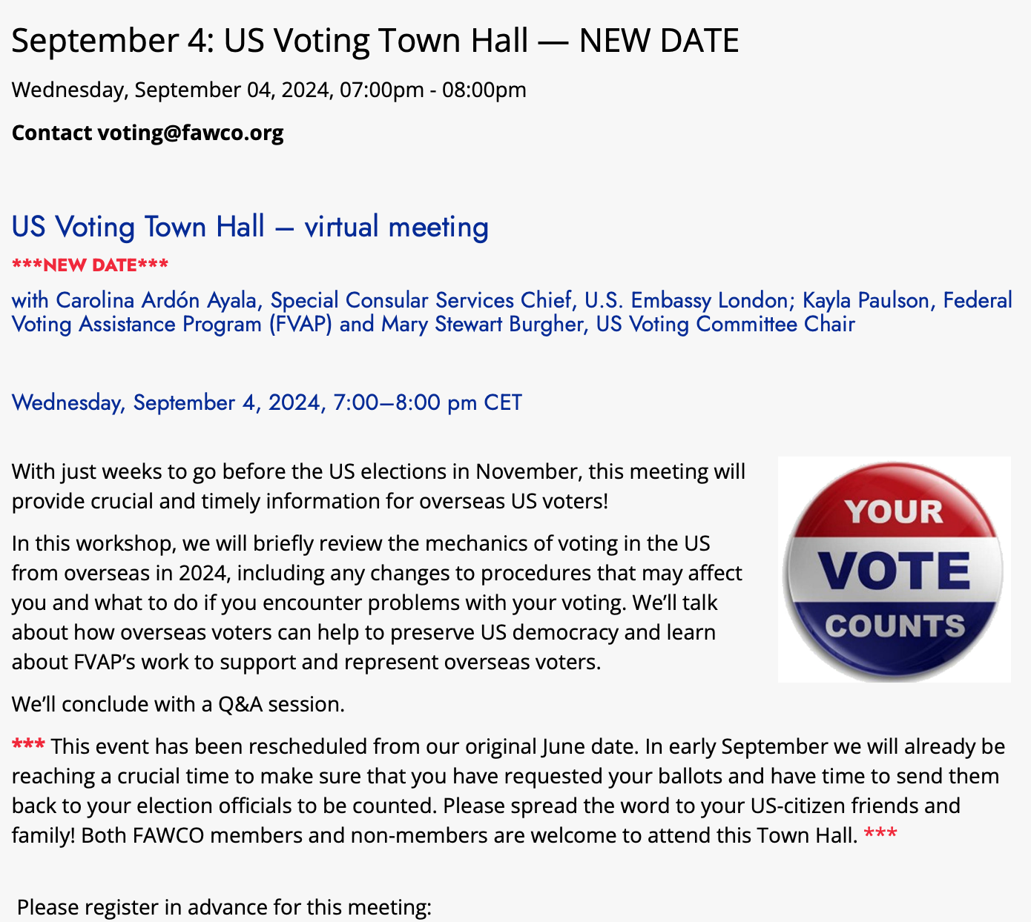

<https://us02web.zoom.us/meeting/register/tZAtfumoqj4uG9VUO_Ny6VKIWWzWmBcRulBS>

After registering, you will receive a confirmation email containing information about joining the meeting. Location virtual.